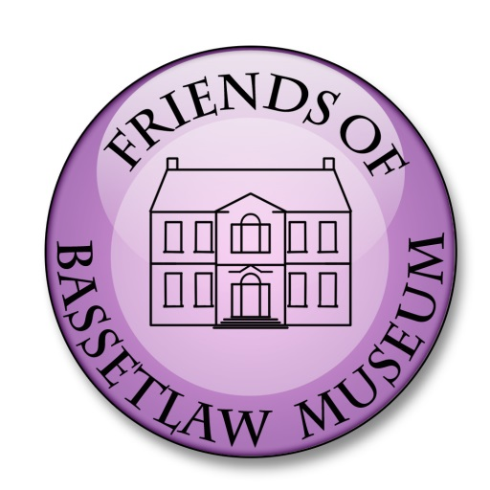
Friends of Bassetlaw Museum
c/o Bassetlaw Museum
Amcott House
40 Grove Street
Retford
Notts DN22 6LD
Email: fobm.membership@gmail.com
Tel: 01777 713749

Membership Application Form

Please complete this form to become a member of the Friends of Bassetlaw Museum (FoBM).

To make your membership application, please complete and return this form together with a cheque for the correct payment for the attention of Derek Turner, Treasurer to the above address. Cheques made payable to ‘Friends of Bassetlaw Museum’. Alternatively, if you wish to pay via on-line banking please complete and return this form to the museum for the attention of Derek Turner and use the details below to make payment. Please ensure you use your Initial(s) and Surname as payment reference: -

Account Name: ‘Friends of Bassetlaw Museum’
Bank: NatWest
Sort Code: 60-17-28
Account No: 90211413.

Name 1: …………………………………. . Name 2: ………………………………….

Email 1: …………………………………. Email 2: ………………………………….

Contact No. 1: …………………………… Contact No. 2: ……………………………

Address 1: ……………………………….. Address 2: ………………………………..

……………………………………………. …………………………………………….

Please select:

◻ Adult @ £8.00 per annum ◻ Number of Membership(s)

◻ Junior (under 18) @£5.00 per annum ◻ Number of Membership(s)

◻ Corporate @ £25.00 per annum

I understand that all information collected and stored by FoBM will be held on a databace, used only by FoBM and not passed to any third parties. By signing this form I give permission for FoBM to send information to me via email and/or post.

Signed: …………………………………………………………………………..

Dated: ……………………………………………………………………………

